5/11/2022
Scripting project
Made by Ryan Habis
Ryan Habis

Contents
Introduction to Assignment 2
Purpose of the script 2
Script code (With comments) 2
Problems encountered 7
Output of script 8
Below is a demonstration of the script running 8
The copy of the receipt to the desktop. 9
What the bill of all the food items ordered by the customer. 9
Conclusion 10
Bibliography 11

Introduction to Assignment
In this assignment the task was to build a script that to incorporate as many features as possible on a topic the student as picked in this script it mimics a fast-food ordering system.
It has assigning values to variables, while loops and conditional statements.

Purpose of the script
The student created a script that mimics a fast-food ordering system, a customer can order their meal without having the need to interact with another person it is simple to user and not overly complicated system for the customer, this is a good thing because when a customer is ordering food they want to order and receive the food as fast as possible especially from a fast-food restaurant.

Script code (With comments)

#order_food_script
#******************
# Header

# 1) Introduction:
# Creator: Ryan Habis - D00245309
# Purpose/Descripting: This script alows customers to order a meal from a fast food restaurant
# Version: 3
# Last edited: 11/05/2022
# Copyright: Ryan Habis

# 2) Purpose of the script:
#
# 3) Order or opperation

# A) Show costumer list of food items.

# B) Ask customer to select an item.

# C) Does the customer want something else?

# D) If yes have a while loop going until the answer is no

# 4) Problems that arrose:
# The most common problem that arrose was mostly syntax error for example in the if statment I accidently
# typed in -le where it should have been -eq.

# Small issues like that accured but after analising the code I ended up easly trouble shooting the script to a working state

# 5) Conclusion:
# This script mimics' a fast food ordering restaurants
#
#******************

#Body

#Here I am assigning variables
$menu = "Burger" , "Chips" , "Onion rings" , "Cola"

$burger = "Burger"
$chips = "Chips"
$onionRings = "Onion rings"
$cola = "Cola"

$costBurger = 5
$costChips = 2
$costOnionRings = 3
$costCola = 1

#This will output text to the user
Write-Host 'These are what is on the menu:'
$x=0
$bill=0
#This will loop through the menu items and list them 1 to 4
foreach ($i in $menu)
{
$x++
Write-Host $x $i
}

#This is a do while loop it will keep repeating until the user says no
DO
{

#Asking the user to select an item from the menu 1 to 4
$item = Read-Host "Select one of the items listed 1 to 4"

Write-Host $item

# If the user selected a option 1 which is a burger they will be shown what they selected and the cost of it
# As well it add it to the bill total
if($item -eq 1)
{
write-host("You chose the $burger")
write-host("The $burger costs $costBurger euro")
$bill = $bill + $costBurger

}

# If the user selected a option 2 which is chips they will be shown what they selected and the cost of it
# As well it add it to the bill total
elseif($item -eq 2)
{
write-host("You chose the $chips")
write-host("The $chips costs $chips euro")
$bill = $bill + $costChips

}

# If the user selected a option 3 which is a onion rings they will be shown what they selected and the cost of it
# As well it add it to the bill total
elseif($item -eq 3)
{
write-host("You chose the $onionRings")
write-host("The $onionRings costs $costOnionRings euro")
$bill = $bill + $costOnionRings

}

# If the user selected a option 4 which is a soft drink named cola they will be shown what they selected and the cost of it
# As well it add it to the bill total
elseif($item -eq 4)
{
write-host('You chose the ' + $cola + ' drink')
Write-Host('The ' + $cola + ' drink costs ' + $costCola + ' euro')
$bill = $bill + $costCola

}

#This else statment tells the user that they have to pick an option from 1 to 4 anything is wont work
else
{
write-host("Error please select an option from 1 - 4")
}

#Here the user is being asked if they would like to pick another item of the menu
$another = Read-Host "Would you like to pick another? Y/N"
}

#If the user said yes either a lowercase y or uppercase the while loop will start over untill the user selects n or anyother
#charrecter
While ($another -eq 'Y' -OR $another -eq 'y')
{
}

#The user is being asked if they would like a digital copy of the reciept
$recieptPrint = Read-Host "Would you like a copy of the reciept? Y/N"

#If the user said yes either a lowercase y or uppercase Y it will make a textfile on the desktop of the reciept and print
#it to screen

#If the user said no it will print out the reciept on the screen and it wont make a saved copy on the desktop
if($recieptPrint -eq 'Y' -OR $recieptPrint -eq 'y')
{

write-host("A copy of your reciept has been sent to your desktop")

Add-Content -Path "C:\Users\Administrator\Desktop\reciept.txt" -Value "*******************" -Force
Add-Content -Path "C:\Users\Administrator\Desktop\reciept.txt" -Value "Reciept" -Force
Add-Content -Path "C:\Users\Administrator\Desktop\reciept.txt" -Value "Your total is $bill euro" -Force
Add-Content -Path "C:\Users\Administrator\Desktop\reciept.txt" -Value "*******************" -Force

}

#This is a few lines printing a reciept on the screen
Write-Host "*******************"
Write-Host "reciept"

Write-Host "Your total is " $bill " euro"

Write-Host "*******************"

Problems encountered
A problem occurred even before starting creating the script the student wasn’t sure on how to lay out the script in order to resolve the problem, he went in to Microsoft excel and created a flow chart listing out each step along the way of the program so he knew how to structure the script in order to have it fully functional.
Below is the screen shot of the layout used to structure the script, the excel file will be include in the submission folder
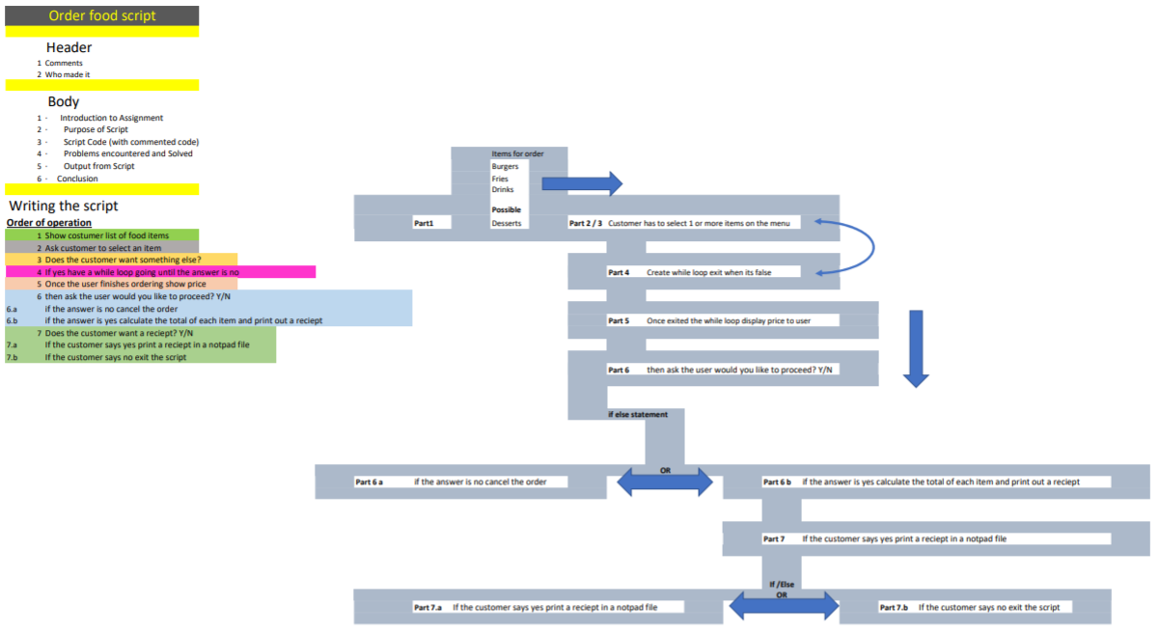

The biggest problems that were encountered was syntax error, there was a few incidents where the student declared the wrong operator in an if statement and had to look over past notes and the internet to resolve the problem at hand.

Output of script

Below is a demonstration of the script running

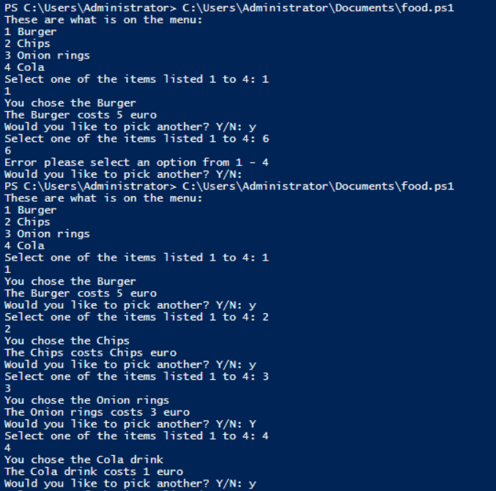

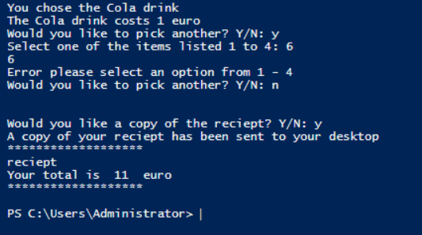

The copy of the receipt to the desktop.
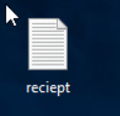

What the bill of all the food items ordered by the customer.
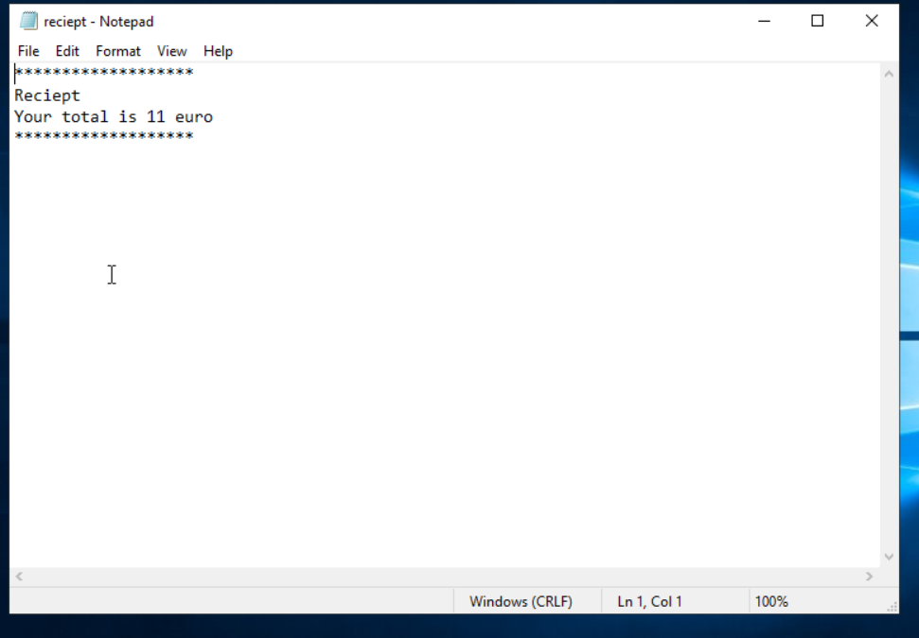

Conclusion
Within this project the student used all the knowledge he gathered and learning from his 1st year.
The purpose of the script is that it is a restaurant ordering system for a fast-food restaurant.
within the script is has comments from the header and the body describing the purpose of the script what which line of code does what.
It has 3 types of variables these variables are listed below
- Direct assignment
- User input
- Positional parameters
The script has a few different types of loops as well lots of if constructors.
Contains a nested if statement and a use for comparison operators.
As well it reads input from the user and saves it as a receipt and prints it into a text file that will be stored on the desktop.

Bibliography
Microsoft, 2022. Add-Content. [Online]
Available at: https://docs.microsoft.com/en-us/powershell/module/microsoft.powershell.management/add-content?view=powershell-7.2
[Accessed 11 05 2022].
Scripto, D., 2014. PowerShell Looping: Understanding and Using Do…While. [Online]
Available at: https://devblogs.microsoft.com/scripting/powershell-looping-understanding-and-using-do-while/
[Accessed 11 05 2022].
tutorialspoint, 2022. Powershell - If Else Statement. [Online]
Available at: https://www.tutorialspoint.com/powershell/if_else_statement_in_powershell.htm
[Accessed 11 05 2022].

